Simple Chat / Messaging Simulator
1. Introduction
The Simple Chat / Messaging Simulator is a desktop application that simulates a basic chat system. The goal of this project is to show how software design patterns can be used to build a simple, flexible, and maintainable system.
Key Features:
- Send and receive messages
- Styled messages using decorators
- Notifications for new messages using Observer pattern
- Chat session management using Builder pattern
- Global chat management using Singleton pattern
- Message creation using Factory Method
The app simulates a chat between a user and a bot. Users can send messages, see responses, and get notifications for new messages.

2. Design Pattern Usage
2.1 Factory Method – MessageFactory
- Problem it solves: Helps to create different types of messages easily without changing other parts of the code.
- How implemented: MessageFactory creates TextMessage or EmojiMessage based on the type.
- Classes involved: Message (interface), TextMessage, EmojiMessage, MessageFactory
- UML Diagram: 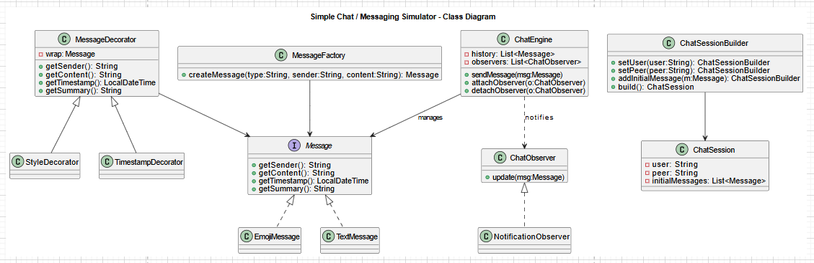
2.2 Builder – ChatSessionBuilder
- Problem it solves: Helps to create a chat session step by step with user, peer, and initial messages.
- How implemented: ChatSessionBuilder sets user, peer, adds initial messages, and builds a ChatSession.
- Classes involved: ChatSession, ChatSessionBuilder

2.3 Decorator – Message Styling
- Problem it solves: Adds extra features to messages (like timestamp and bold) without changing the main message classes.
- How implemented:
  - TimestampDecorator adds the time to the message
  - StyleDecorator can make message text bold if needed
- Classes involved: MessageDecorator, TimestampDecorator, StyleDecorator

UML Diagram:
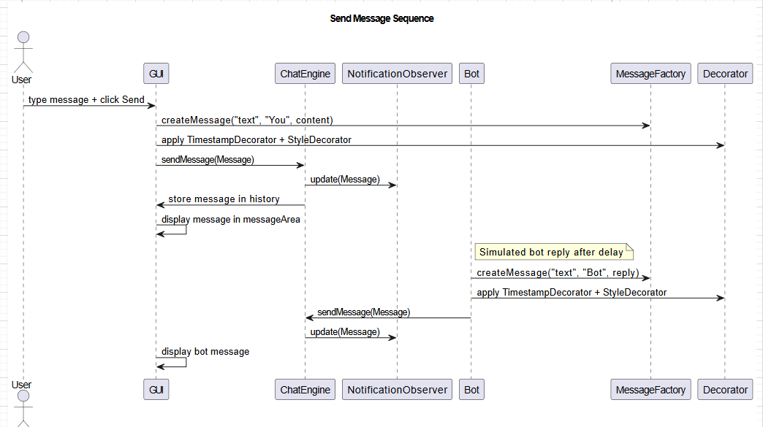

2.4 Observer – NotificationObserver
- Problem it solves: Sends notifications for new messages without tightly coupling sender and receiver.
- How implemented: NotificationObserver listens to ChatEngine and shows popup notifications for incoming messages.
- Classes involved: ChatObserver (interface), NotificationObserver

2.5 Singleton – ChatEngine
- Problem it solves: Keeps one global chat manager to handle all messages and observers.
- How implemented: ChatEngine stores chat history, manages observers, and routes messages.
- Classes involved: ChatEngine

UML Diagram:
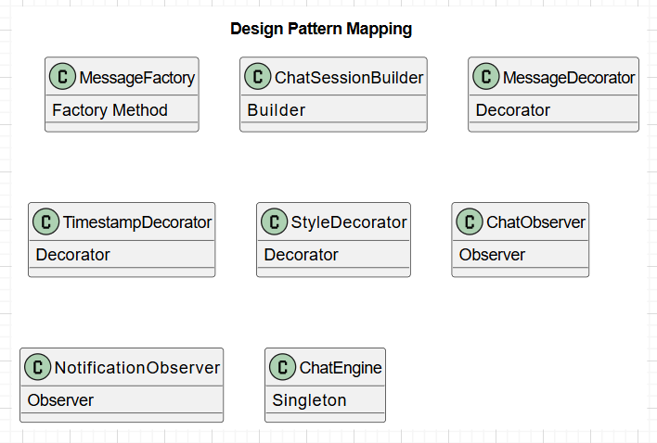

3. Implementation Details
- Language: Java
- Framework: JavaFX
- Libraries used: JavaFX (built-in controls)
- Code editor and compiler: Net Bean
- Code structure:
  - Single Java file: SimpleChatSimulator.java
  - Conceptual packages: Factory, Builder, Decorator, Observer, Core (ChatEngine)
- Key Methods:
  - sendUserMessage() – Sends user message
  - autoReply() – Bot reply logic
  - displayMessage() – Shows messages in GUI

4. Screenshots / Output
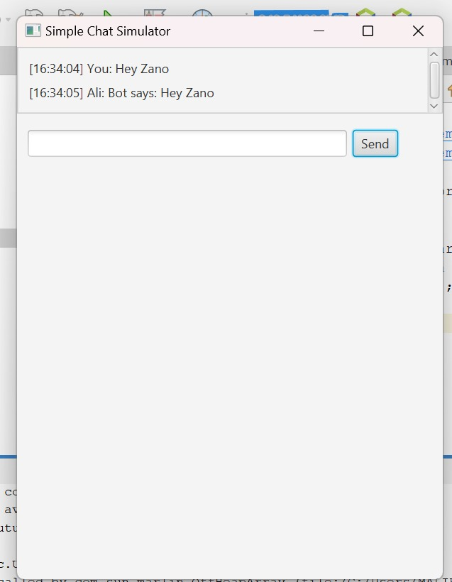
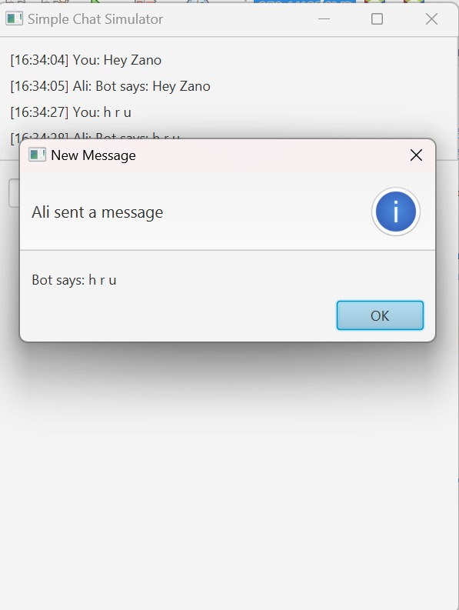
5. Challenges and Solutions
- Challenge: Displaying real-time notifications without freezing the GUI
  - Solution: Used Platform.runLater and separate threads for bot reply and popup notifications
- Challenge: Applying decoration to messages dynamically
  - Solution: Used Decorator pattern to wrap messages with timestamp and style
- Challenge: Managing chat history and multiple observers
  - Solution: Implemented Singleton pattern for ChatEngine

6. Conclusion / Future Work
The Simple Chat / Messaging Simulator shows how software design patterns can be used in a small desktop application. The project demonstrates Factory, Builder, Decorator, Observer, and Singleton patterns successfully.
Future improvements:
- Add multiple users chat support
- Save/load chat history
- Add message search and filtering
- Add emoji picker and rich media messages

